ML Lab 3

Name: Saptanshu Wanjari

Class: A-A2

Roll No: 18
Lab No.: 3
Lab Aim and Objective: To implement concept learning algorithms, Find-S and Candidate Elimination, on the EnjoySport dataset and find a hypothesis that matches all training examples.
Dataset or Resources Used: EnjoySport dataset (enjoy.csv, 10 records, 7 columns). Tools: Python, pandas, numpy, matplotlib, seaborn, Jupyter Notebook.
Date of Performance: 12 August 2026

1. Theory

1.1 What is Concept Learning?
Concept learning means inferring a boolean function that classifies examples as positive or negative, given a set of training examples. Each example is described by attributes like Sky, AirTemp, Humidity, Wind, Water and Forecast, and the target EnjoySport tells if we enjoy the sport that day or not. A hypothesis is a conjunction of constraints over these attributes, where each constraint can be a specific value or '?' which means any value is allowed.

1.2 Find-S Algorithm
Find-S starts with the most specific hypothesis (None or the first positive example) and only updates it on positive examples. For each positive example it replaces attribute values that differ from the current hypothesis with '?'. So the hypothesis keeps getting more general till it covers all positive examples. It ignores negative examples completely, which is a limitation.

1.3 Candidate Elimination Algorithm
Candidate Elimination keeps two boundaries of the version space: S, the most specific hypothesis consistent with the data, and G, the most general hypotheses. For a positive example it generalizes S, and for a negative example it specializes G so the negative example is not covered. The version space is the set of all hypotheses between S and G that are consistent with all examples.

2. Code with GitHub URL
The complete code for this lab is written in a Jupyter Notebook and uploaded to GitHub:
https://github.com/SaptanshuWanjari/3rd-Year-/blob/main/ML/lab/12-8-Lab3-Enjoy/A-A2-18_Saptanshu-Wanjari-Lab3-Enjoy.ipynb
https://github.com/SaptanshuWanjari/3rd-Year-/blob/main/ML/lab/12-8-Lab3-Enjoy/A-A2-18_Saptanshu-Wanjari-Lab3-Enjoy.py
The complete written code is given below:
#!/usr/bin/env python
# coding: utf-8
# # ML Lab 3
# ## Name: Saptanshu Wanjari
# ### Class: A A2
# ### Roll No: 18
# In[1]:
import numpy as np
import pandas as pd
import matplotlib.pyplot as plt
import seaborn as sns
# In[2]:
data = pd.read_csv("enjoy.csv")
print("Shape:", data.shape)
data.head()
# In[3]:
data.info()
print()
data.describe()
# In[4]:
print("Missing values per column:")
print(data.isnull().sum())
print("\nTotal missing:", data.isnull().sum().sum())
# In[5]:
dup = data.duplicated().sum()
print("Duplicate rows:", dup)
print("Total rows:", len(data))
print("Unique rows:", len(data) - dup)
# In[6]:
data_encoded = data.copy()
for col in data_encoded.columns:
data_encoded[col] = data_encoded[col].astype('category').cat.codes
print("Encoded (0/1/2/... per category):")
data_encoded.head()
# In[7]:
fig, axes = plt.subplots(3, 3, figsize=(15, 12))
axes = axes.flatten()
for i, col in enumerate(data.columns):
data[col].value_counts().plot(kind='bar', ax=axes[i], color='skyblue')
axes[i].set_title(col)
axes[i].set_xlabel('')
plt.tight_layout()
plt.show()
# In[8]:
sns.countplot(x='EnjoySport', data=data, palette='Set2')
plt.title('EnjoySport target distribution')
plt.show()
print(data['EnjoySport'].value_counts())
# In[9]:
X = data.iloc[:, :-1].values
y = data.iloc[:, -1].values
print("X (features):\n", X)
print("\ny (target):\n", y)
print("\nX shape:", X.shape, "| y shape:", y.shape)
# In[10]:
def find_s(X, y):
hypothesis = None
print("Initial hypothesis:", hypothesis)
for i in range(len(X)):
if y[i] == "Yes":
if hypothesis is None:
hypothesis = X[i].copy()
else:
for j in range(len(hypothesis)):
if hypothesis[j] != X[i][j]:
hypothesis[j] = '?'
print("\nAfter training example", i + 1, ":", hypothesis)
return hypothesis
final_hypothesis = find_s(X, y)
print("\nFinal hypothesis:", final_hypothesis)
# In[11]:
def covers(g, h):
return all(g[j] == "?" or g[j] == h[j] for j in range(len(g)))
def candidate_elimination(concepts, target):
S = concepts[0].copy()
G = [["?" for _ in range(len(S))]]
print("Initial S:", S)
print("Initial G:", G)
for i, (h, t) in enumerate(zip(concepts, target)):
if t == "Yes":
for j in range(len(S)):
if S[j] != h[j]:
S[j] = "?"
G = [g for g in G if covers(g, h)]
else:
keep, spec = [], []
for g in G:
if covers(g, h):
for j in range(len(g)):
if g[j] == "?" and S[j] != "?":
s2 = list(g)
s2[j] = S[j]
if not covers(s2, h) and s2 not in spec:
spec.append(s2)
else:
keep.append(g)
G = keep + spec
dedup, seen = [], set()
for g in G:
k = tuple(g)
if k not in seen:
seen.add(k)
dedup.append(g)
G = [g for g in dedup if not any(
g != g2 and all(g2[j] == "?" or g2[j] == g[j] for j in range(len(g)))
for g2 in dedup)]
print("\nAfter example", i + 1, "(" + t + "):")
print("S:", S)
print("G:", G)
return S, G
S, G = candidate_elimination(X, y)
print("\nFinal S:", S)
print("Final G:", G)
# ## Result
#
# The Find-S algorithm gives a final hypothesis of `['Sunny', 'Warm', '?', '?', '?', '?']`, and Candidate Elimination converges S and G to the same single hypothesis, which means the version space holds exactly one consistent concept.

3. Procedures and Materials Used

3.1 Materials Used
• Hardware: A laptop/computer with internet access.
• Software: Python 3, Jupyter Notebook, pandas, numpy, matplotlib, seaborn, VS Code or any editor.

3.2 Procedure
1. Loaded the EnjoySport dataset enjoy.csv using pandas and printed its shape and first few rows.
2. Checked the data types, missing values and duplicate rows in the dataset.
3. Label encoded all the categorical columns so the values become numbers.
4. Plotted bar charts for all the attributes and a count plot for the target column.
5. Separated the features X and the target y from the dataset.
6. Implemented the Find-S algorithm and ran it on X and y.
7. Implemented the Candidate Elimination algorithm with an S and G boundary and ran it.
8. Noted the final hypothesis from both algorithms and compared them.

4. Output Screenshots with Descriptions

Output 1 – Dataset loaded and first 5 rows
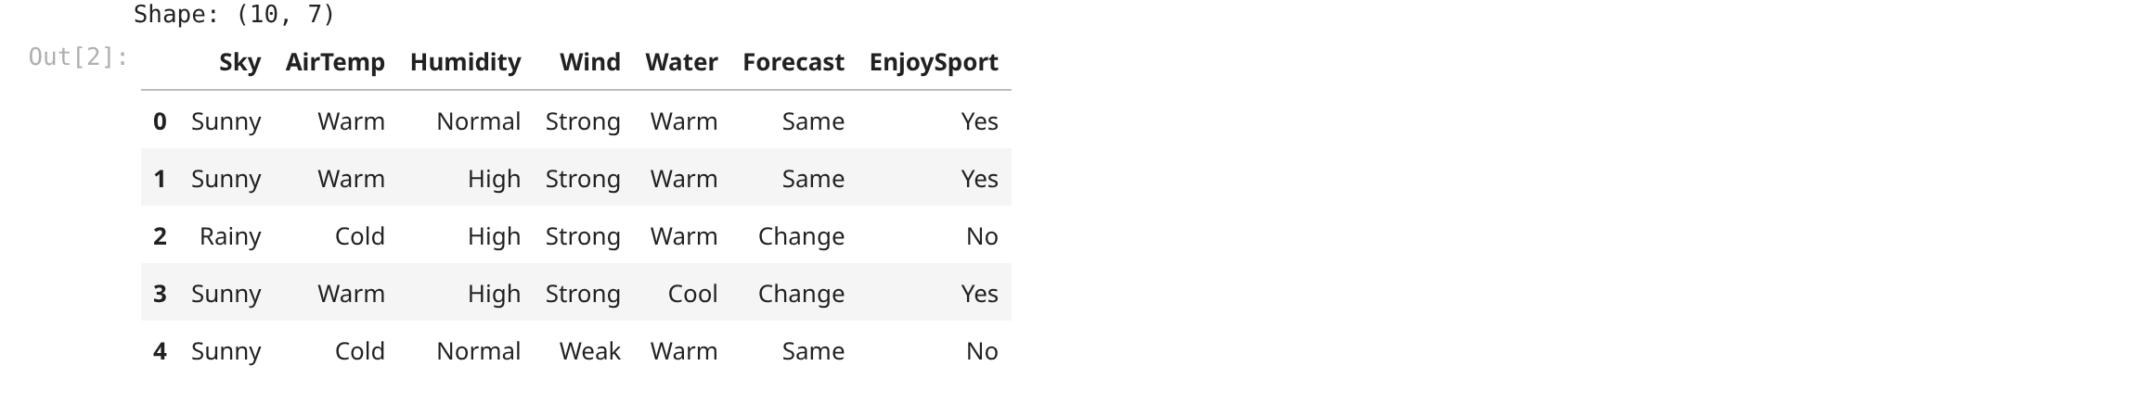
First 5 rows of the EnjoySport data. You can see there are 10 rows and 7 columns. The columns are Sky, AirTemp, Humidity, Wind, Water, Forecast and the target EnjoySport. All values are categorical like Sunny, Warm, Normal and so on.

Output 2 – Data info and describe
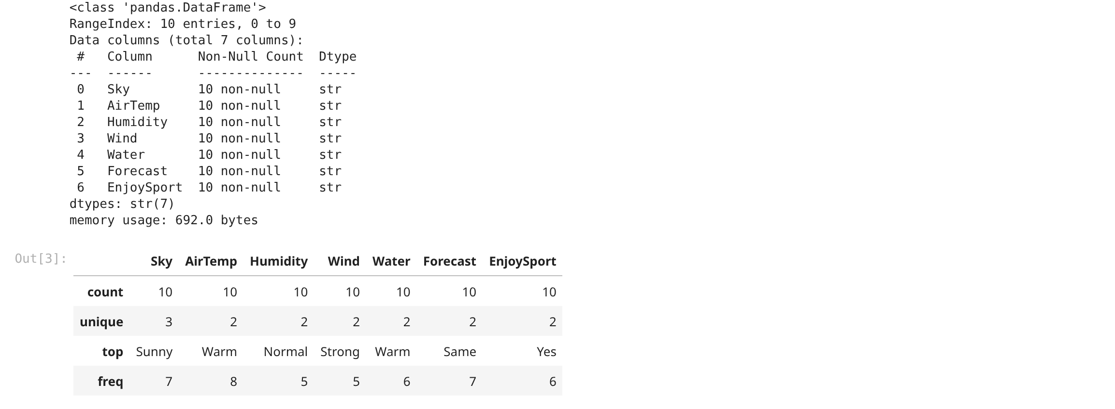
Here I checked the structure with data.info(). All 7 columns are string type and there are no null values. The describe table shows the most common value of each column, like Sunny appears 7 times in Sky and Warm 8 times in AirTemp.

Output 3 – Missing values count
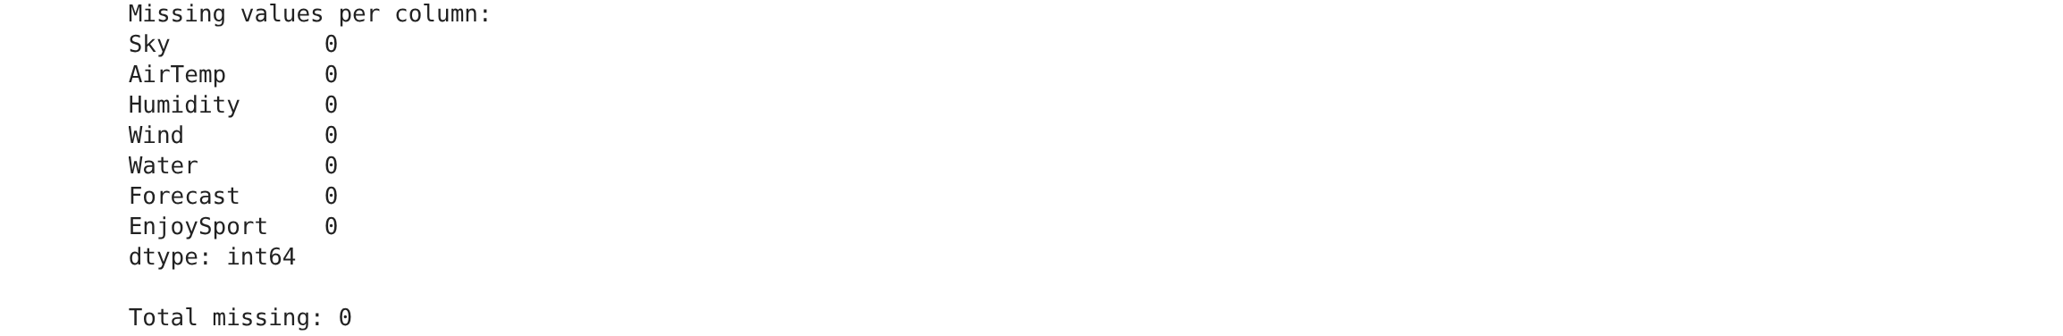
I checked missing values for every column. Every column shows 0 missing values so the total is 0. This dataset is small and clean, so there is nothing to impute.

Output 4 – Duplicate row check
Duplicate rows are 0 out of 10 total rows. So all 10 rows are unique and no example is repeated in the dataset.

Output 5 – Label encoded data
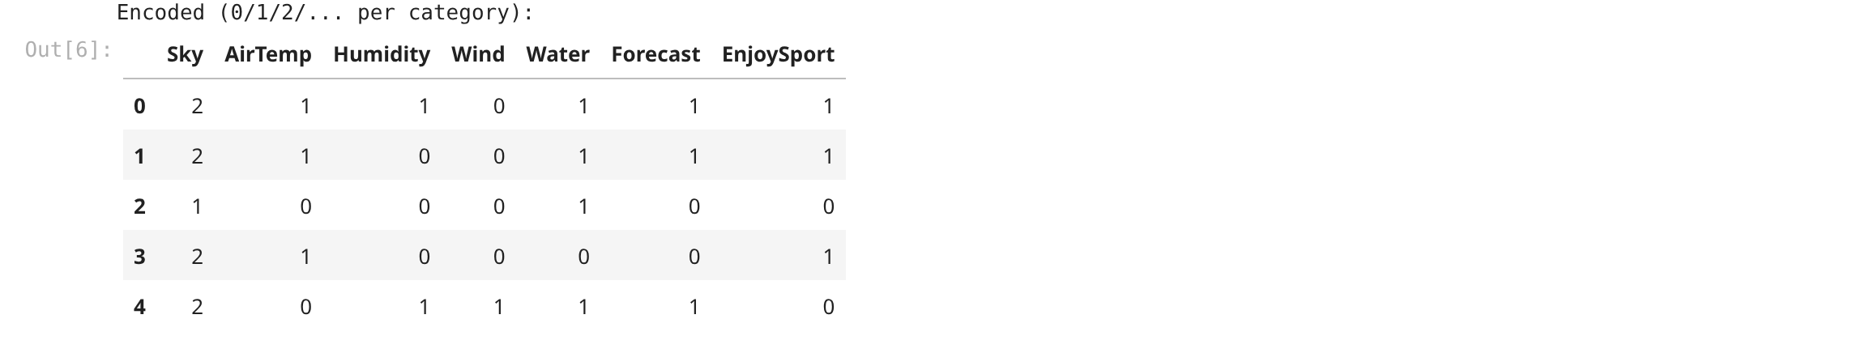
All the categorical columns are converted to numbers using category codes. So Sky becomes 2 for Sunny and EnjoySport becomes 1 for Yes. You can see the encoded first 5 rows here.

Output 6 – Bar charts of all attributes
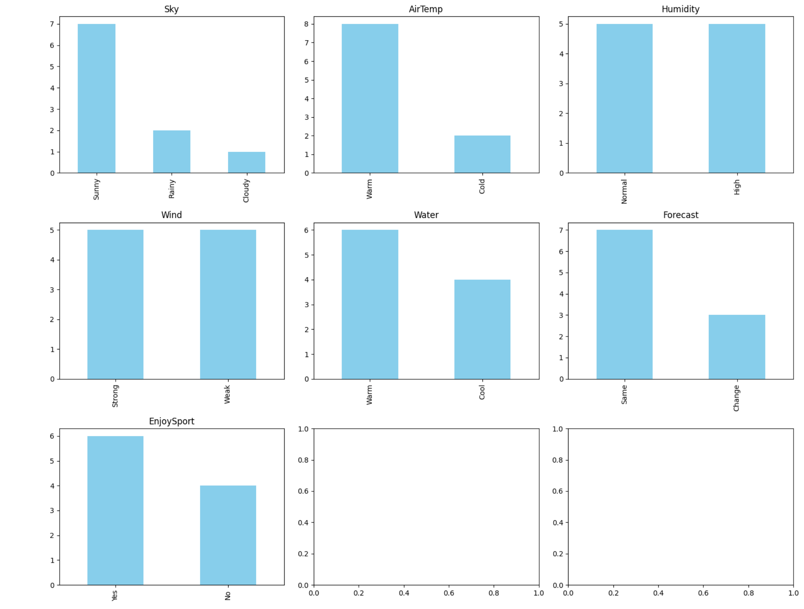
Bar plots for all 7 columns. Sunny is the most common Sky, Warm is the most common AirTemp. The EnjoySport chart shows Yes appears more often than No.

Output 7 – EnjoySport target distribution
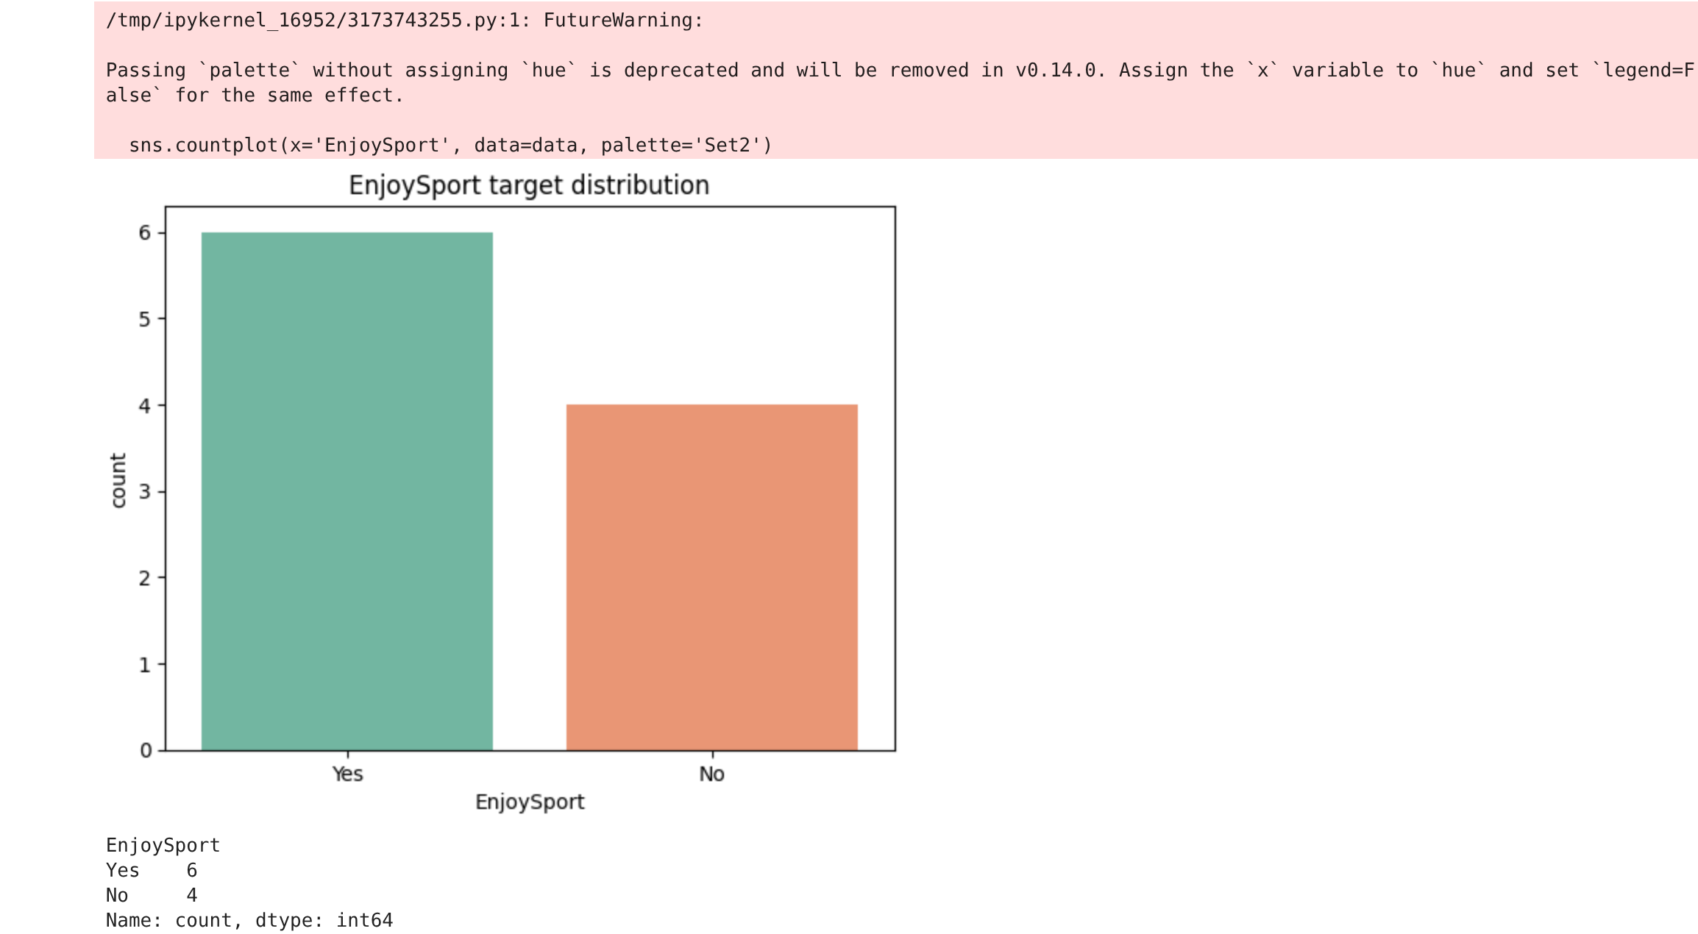
A count plot for the target column. Yes appears 6 times and No appears 4 times out of 10. So the data has a few more positive examples than negative.

Output 8 – Features X and target y split
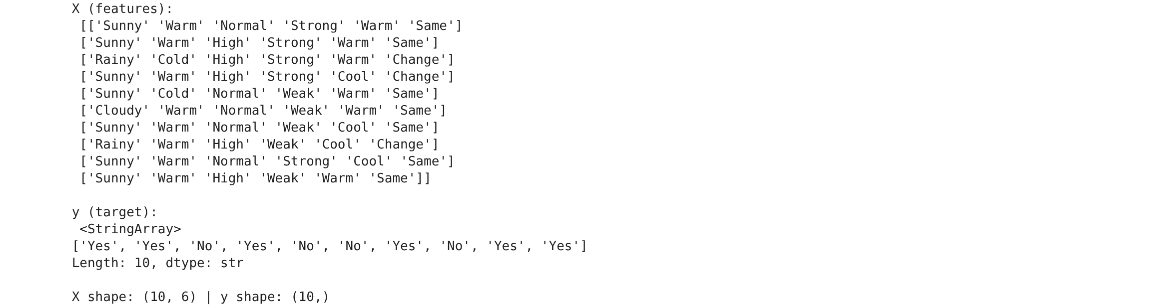
I split the data into X (features) and y (target). X holds the 6 attribute columns and y holds the EnjoySport column. X shape is (10, 6) and y shape is (10,).

Output 9 – Find-S algorithm output
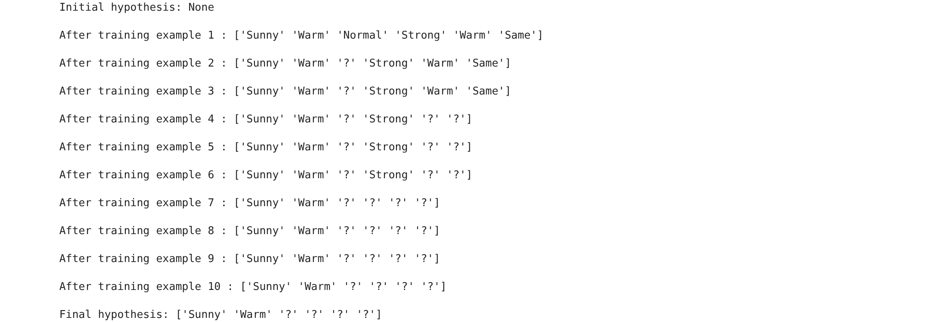
The Find-S algorithm output. It starts with None, then picks the first positive example Sunny Warm Normal Strong Warm Same. After generalizing on positive examples the final hypothesis becomes ['Sunny', 'Warm', '?', '?', '?', '?'].

Output 10 – Candidate Elimination output
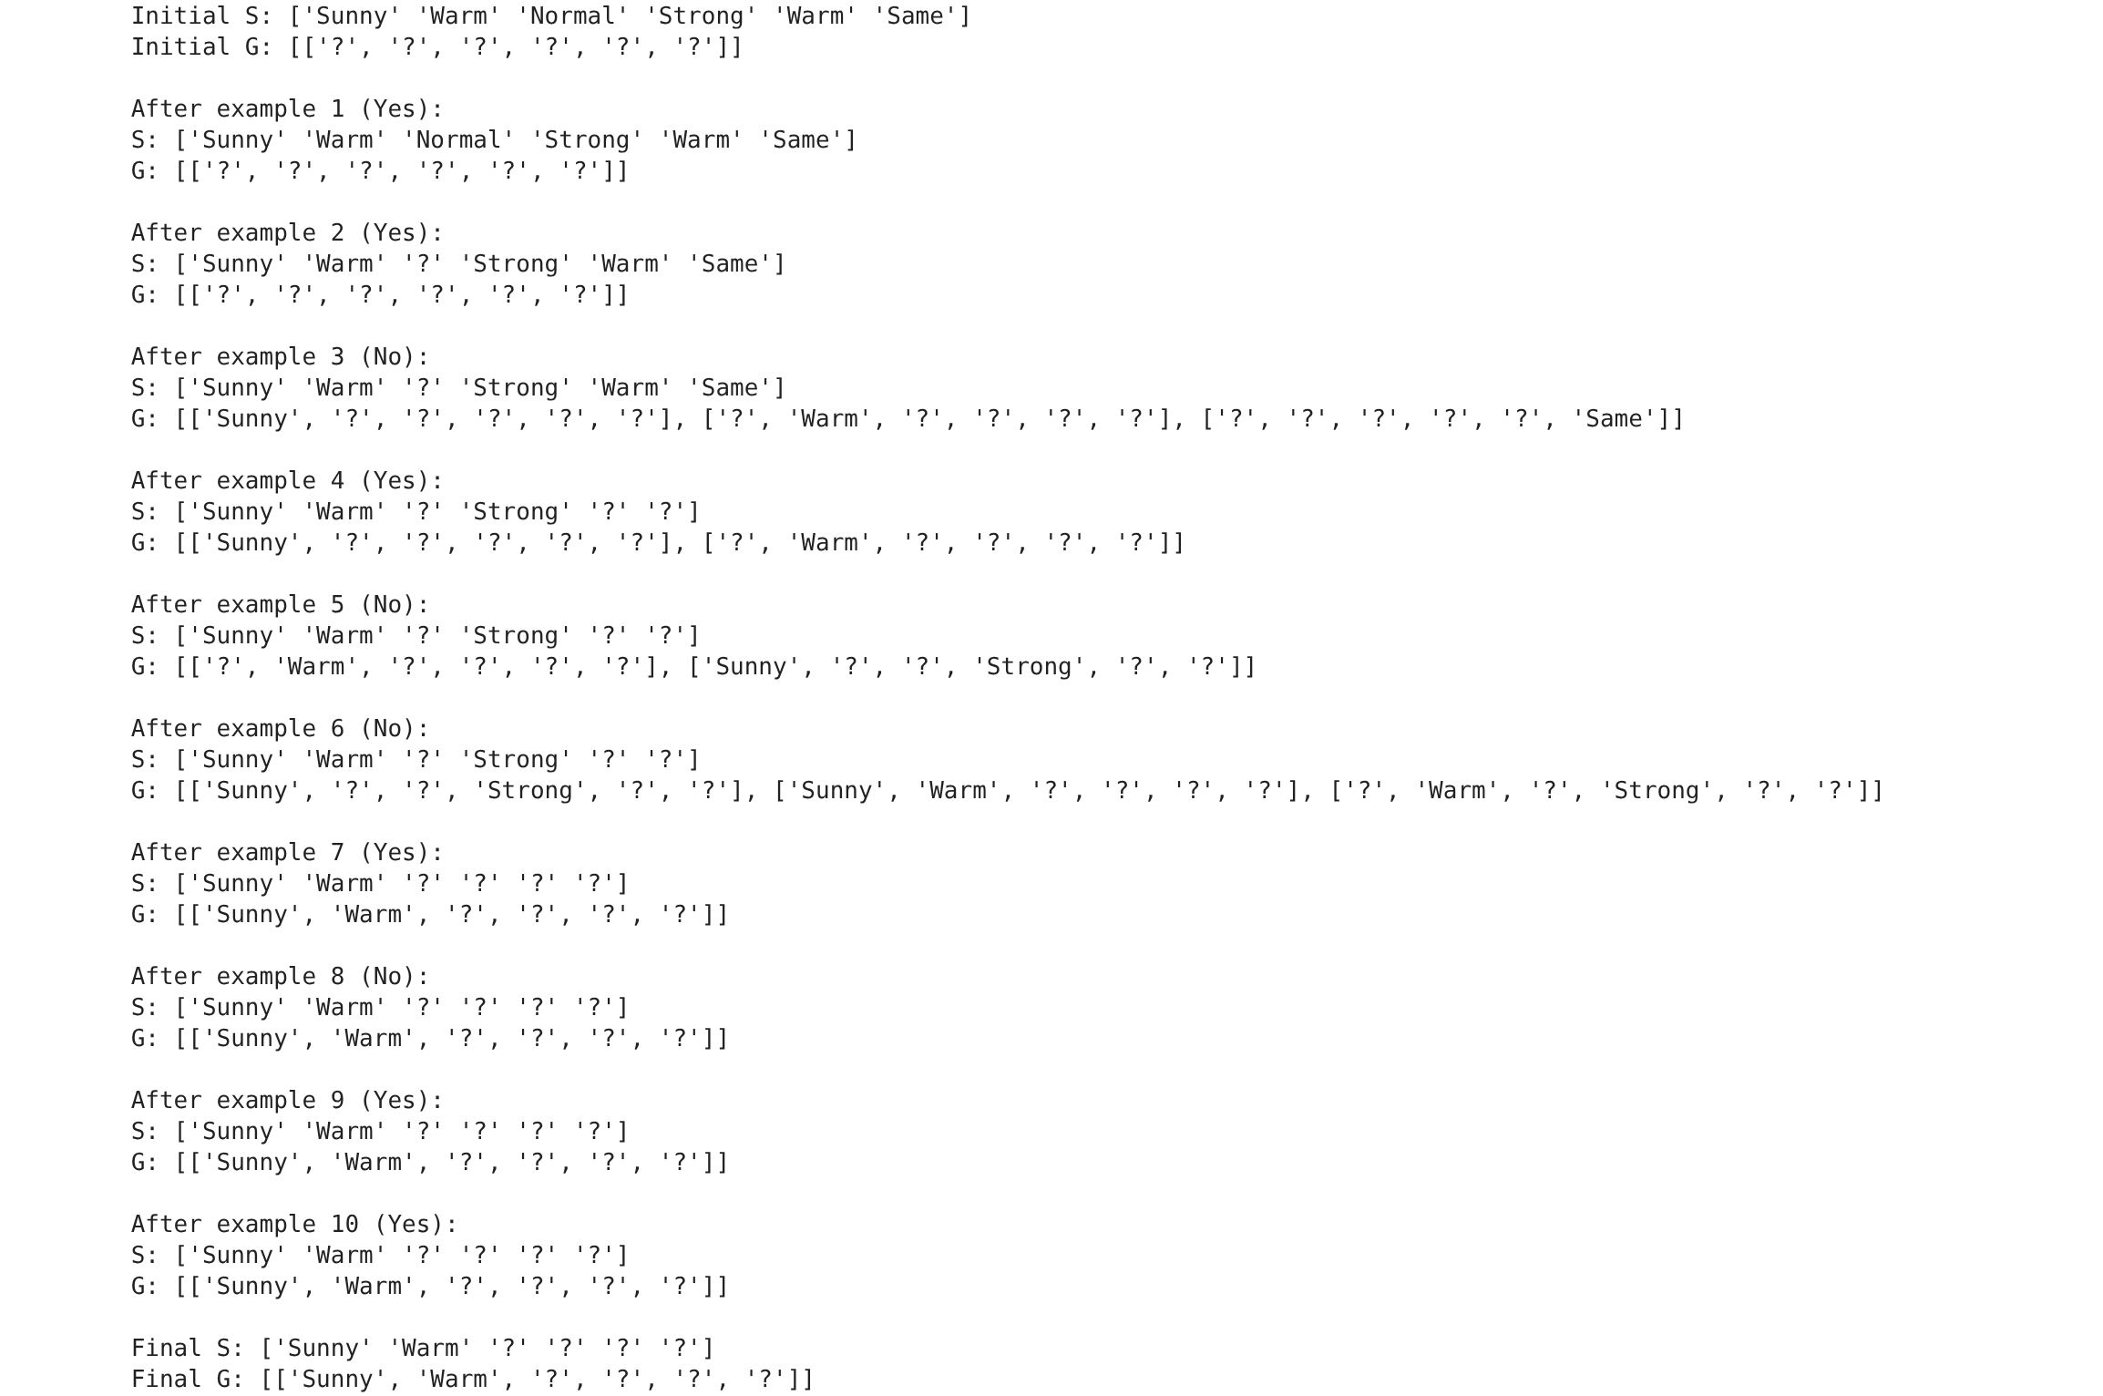
Candidate Elimination keeps S and G boundaries. After processing all 10 examples, S and G both converge to ['Sunny', 'Warm', '?', '?', '?', '?']. So the version space has only one hypothesis, meaning we enjoy sport on sunny and warm days.

5. Viva Questions and Solutions
Q1. What is concept learning?
Solution: Concept learning is inferring a boolean valued function from training examples. The function says whether an example is positive or negative. In this lab the target EnjoySport is positive (Yes) when we enjoy the sport and negative (No) when we do not.
Q2. What is a hypothesis in concept learning?
Solution: A hypothesis is a conjunction of constraints over the attributes. Each attribute can have a specific value, a range, or '?' which means any value is allowed. An empty hypothesis (no constraints) covers all examples and a fully specific one covers only that exact example.
Q3. How does the Find-S algorithm work and what is its limitation?
Solution: Find-S starts with the most specific hypothesis and only generalizes it using positive examples. For a positive example, any attribute value that differs from the current hypothesis is changed to '?'. Its limitation is that it ignores negative examples, so it cannot detect noise and the final hypothesis may still be inconsistent.
Q4. What is the version space?
Solution: The version space is the set of all hypotheses that are consistent with the training data. It is represented by two boundaries, S which is the most specific hypothesis and G which is the most general hypothesis. Every consistent hypothesis lies somewhere between S and G.
Q5. What did we conclude from the results?
Solution: Both Find-S and Candidate Elimination gave the same final hypothesis ['Sunny', 'Warm', '?', '?', '?', '?']. This means the version space has a single hypothesis, so we enjoy the sport only on days that are sunny and warm, and the other attributes do not matter.

